Chapter No.5
DATABASE

DATABASE
5.1 Database
A database is an application that manages data and allows fast storage and retrieval of that data.
A database is a collection of data, which is organized in such a way that each piece of data is available to those who need it and with minimum duplication of data.
There are different types of database but the most popular is a relational database that stores data in tables where each row in the table holds the same sort of information. In the early 1970s, Ted Codd, an IBM researcher devised 12 laws of normalization. These apply to how the data is stored and relations between different tables.
5.2 Advantages of Database
The most common advantages of database may be as follows.
- Minimal data redundancy
- Consistency of data
- Data integrity
- Sharing of data
- Ease of application development
- Uniform security, privacy and integrity controls
- Reduced program maintenance
- Improved data security
5.3 Disadvantages
- Database systems are complex, difficult, and time-consuming to design
- Substantial hardware and software start-up costs
- Damage to database affects virtually all applications programs
- Extensive conversion costs in moving form a file-based system to a database system
- Initial training required for all programmers and users
5.4 Constraints
These are the conditions that obey database.
5.5 Entity
Any object of concept identified by an enterprise that exists independently and about which it is necessary to store data. It may be anything like a person, a place, an event or concept or an object.
5.6 Attributes
An attribute is the Characteristics or property of an entity that is of interest to the organization.
For example, student is an entity; its attributes mostly may be student’s roll no, name, address marks, etc.
5.7 Keys
A key is a distinct for each individual entity in an entity set. Key attributes are the attributes whose values are uniquely identified and do not exist again.

5.7.1 Super key
A super key is an attribute or a set of attributes that uniquely identifies an entity. For example, student-id is a super key because it can be used to identify each student uniquely.

5.7.2 Candidate key
It is also a super key. If A= {studentid, name} then its proper subsets are {studentid} and {name}, then its subset is itself. It means that extra attributes are removed from the super key.

5.7.3 Primary key
The primary key is the successful candidate key, the one actually chosen. It may be a single attribute or composite key. The term secondary key is used to mean alternate key but secondary key usually means an attribute or set of attributes whose values not necessarily unique, are used as a mean of accessing records.

5.7.4 Foreign key
A foreign key is an attribute or combination of attributes of an entity that is primary key of another entity.

5.7.5 Composite key
If the key consists of more than one attribute for unique identification then it will be called as composite key.

5.8 Normalization
A relation is in specified normal form if it satisfies the set of requirements or constraints of that form. The major concept used from the relation data model, used in the developing the conceptual model in this system, is the normalization process. Infect normalization process is the process of grouping the data elements. Its simplest definition will be “The process of converting complex data structure into simple stable data structure”.

Anomalies are the errors or inconsistencies that may result when a user attempts to update a table that contains the redundant data. There types of anomalies are insertion, deletion and the modification. So another definition of normalizes will be;
“Normalization is the process through which we remove insertion, deletion and updating of anomalies of the database.”
The definition of the three normal forms is given below:
5.8.1 First Normal Form (INF)
A relation is in first normal form if every cell o a table must contain an atomic value.
5.8.2 Second Normal Form (2NF)
A relation is in second normal form if it is in first normal form and every non-key attributes fully functionally dependent on the primary key.
5.8.3 Third Normal Form (3NF)
A relation is in third normal form if and only if it is in second normal form and no non-key attribute is transitively dependent on the primary key. It is also stated as “A relation is in third normal form, if it is in second normal form and no transitive dependencies exist”.
5.8.4 Higher Normal Forms
There are several higher normal forms, including 4NF, 5NF, BCNF, and PJ/NF. We’ll leave our discussion at 3NF, which is adequate for most practical needs. If you are interested in higher normal forms, consult a book like Date’s An Introduction to Database Systems.

5.9 Background to Normalization

5.9.1 Functional Dependency
In a given table, an attribute Y is said to have a functional dependency on a set of attributes X (written X → Y) if and only if each X value is associated with precisely one Y value. For example, in an "Employee" table that includes the attributes "Employee ID" and "Employee Date of Birth", the functional dependency {Employee ID} → {Employee Date of Birth} would hold.
5.9.2 Trivial Functional Dependency
A trivial functional dependency is a functional dependency of an attribute on a superset of itself. {Employee ID, Employee Address} → {Employee Address} is trivial, as is {Employee Address} → {Employee Address}.
5.9.3 Full Functional Dependency
An attribute is fully functionally dependent on a set of attributes X if it is

Functionally dependent on X, and

Not functionally dependent on any proper subset of X. {Employee Address} has a functional dependency on {Employee ID, Skill}, but not a full functional dependency, because it is also dependent on {Employee ID}.
5.9.4 Transitive Dependency
A transitive dependency is an indirect functional dependency, one in which X→Z only by virtue of X→Y and Y→Z.
5.9.5 Multivalve Dependency
A multivalve dependency is a constraint according to which the presence of certain rows in a table implies the presence of certain other rows.
5.9.6 Join Dependency
A table T is subject to a join dependency if T can always be recreated by joining multiple tables each having a subset of the attributes of T.

5.10 Database Tables
The following tables are maintained to fulfill the requirements of the proposed system. The table name and the field name with its type are also given below with the description of each. The primary key is identified by the symbol of key with that attribute.

- Academic
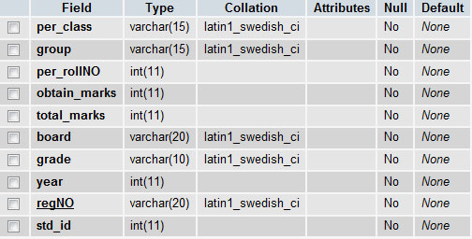

- Admin
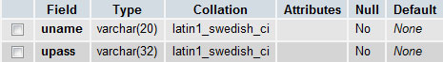

- Admission Detail
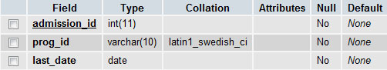

- Combination
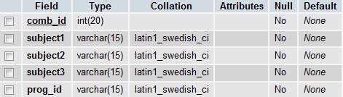
- Combination_has_subject
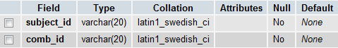
- Merit List
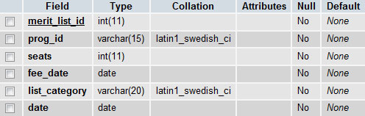
- News
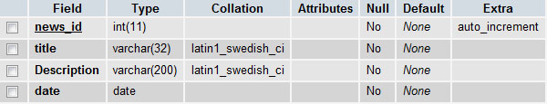

- Program
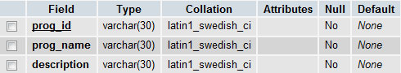

- Student
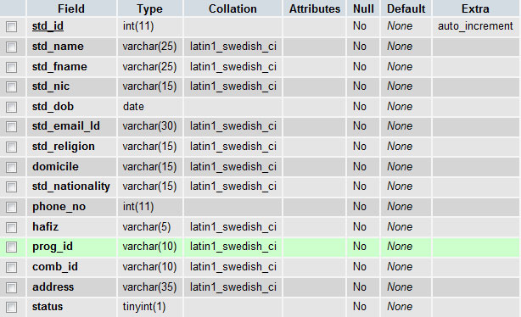
- Subject
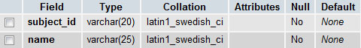

- Teacher

